Name : Aakanksha Aaba Deore

Roll No. : 15

Branch : IT(TE)

Seat No. : T400290471

**ASSIGNMENT**

1. **Illustrate the need of Nodemailer Package.**

In modern web development, sending emails programmatically is a common requirement — for tasks like user registration verification, password resets, notifications, and alerts. Traditionally, setting up an email sending system involved manually configuring SMTP servers, handling security settings, and writing complex code. This process was tedious, error-prone, and difficult to maintain.

* **Manual Email Sending is Tedious**

Setting up low-level SMTP configurations manually can be complex and time-consuming.

* **Error-Prone Process**

Mistakes in SMTP configuration, authentication, and formatting often lead to emails not being delivered or flagged as spam.

* **Nodemailer Provides an Easy Email Sending Solution**

Nodemailer automates and simplifies the process of sending emails from a Node.js application using simple APIs.

* **Built-in Support for SMTP, OAuth2, and More**

Supports traditional SMTP, OAuth2 for Gmail, and other protocols out-of-the-box.

* **Easy Configuration**

Send emails by simply setting the sender, receiver, subject, and body, using straightforward JavaScript code.

* **Handles Attachments and HTML**

Easily send attachments, HTML content, inline images, and rich media emails.

* **Works with Various Email Services**

Compatible with Gmail, Outlook, Yahoo, custom servers, and more.

* **Secure Email Transmission**

Supports encryption (TLS/SSL) and authentication mechanisms for safe delivery.

* **Popular for Web Apps**

Perfect for contact forms, user onboarding emails, e-commerce notifications, and system alerts.

**2. Implement small application which will make use of mentioned package (I/p, O/p).**

**Input:**



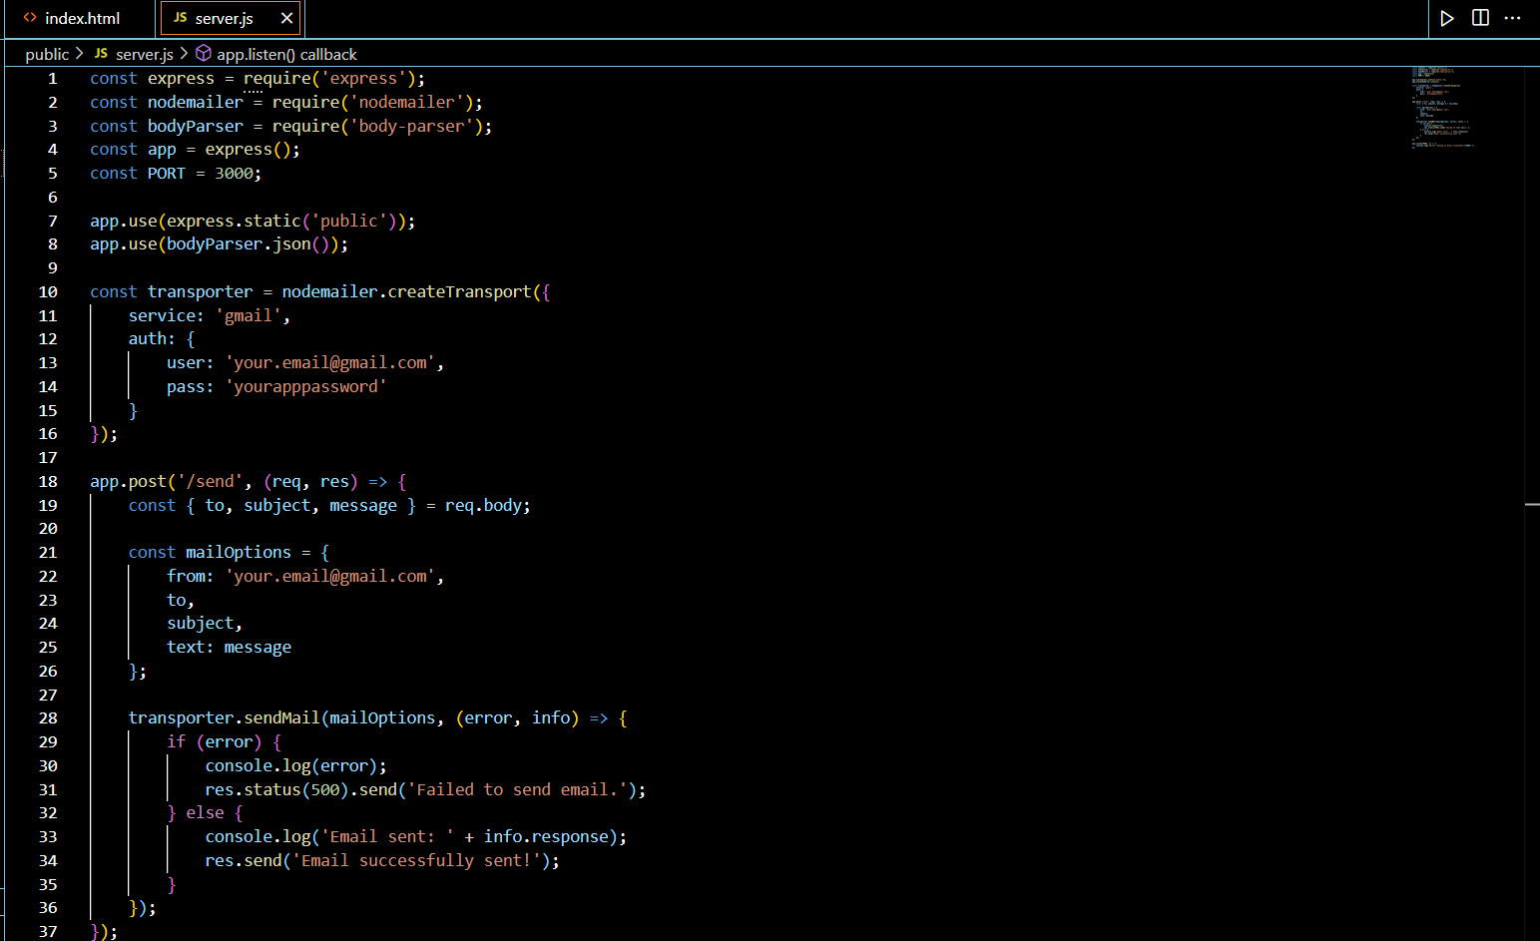

**Output :**





**3.** **Illustrate the need for code of ethics.**

A Code of Ethics is a vital framework that outlines the moral principles and professional standards expected of individuals within an organization, profession, or society. Its primary purpose is to guide behavior, promote integrity, and ensure accountability in decision-making and actions. In any professional setting—be it in business, medicine, engineering, or information technology—a clearly defined code of ethics helps maintain trust among clients, colleagues, and the public. It acts as a moral compass in situations where the right course of action may not be immediately clear. For example, in the tech industry, a code of ethics can help guide decisions around data privacy, user consent, and algorithmic fairness.

* Guides Professional Behavior

Helps individuals make ethical decisions and act responsibly in uncertain situations.

* Builds Trust and Credibility

Enhances trust among clients, customers, colleagues, and the public.

* Promotes Fairness and Justice

Encourages equal treatment, respect, and non-discrimination in professional settings.

* Protects Against Misconduct

Reduces the risk of unethical practices, corruption, or legal issues.

* Handles Ethical Dilemmas in Complex Situations

Useful in areas like data privacy, AI ethics, environmental responsibility, and more.

* Strengthens Organizational Culture

Promotes values such as honesty, accountability, and transparency.

* Provides a Common Ethical Framework

Ensures everyone in an organization understands and follows shared moral standards.

* Supports Continuous Improvement

Encourages reflection on one’s behavior and commitment to personal and professional growth.